**Assignment – 3**

|  |  |
| --- | --- |
| Assignment Date | 01 October 2022 |
| Student Name | SREYANKUMAR S |
| Student Roll Number | 312319104166` |
| Maximum Marks | 2 Mark |

**Question 1:**

Create a Bucket in IBM object storage

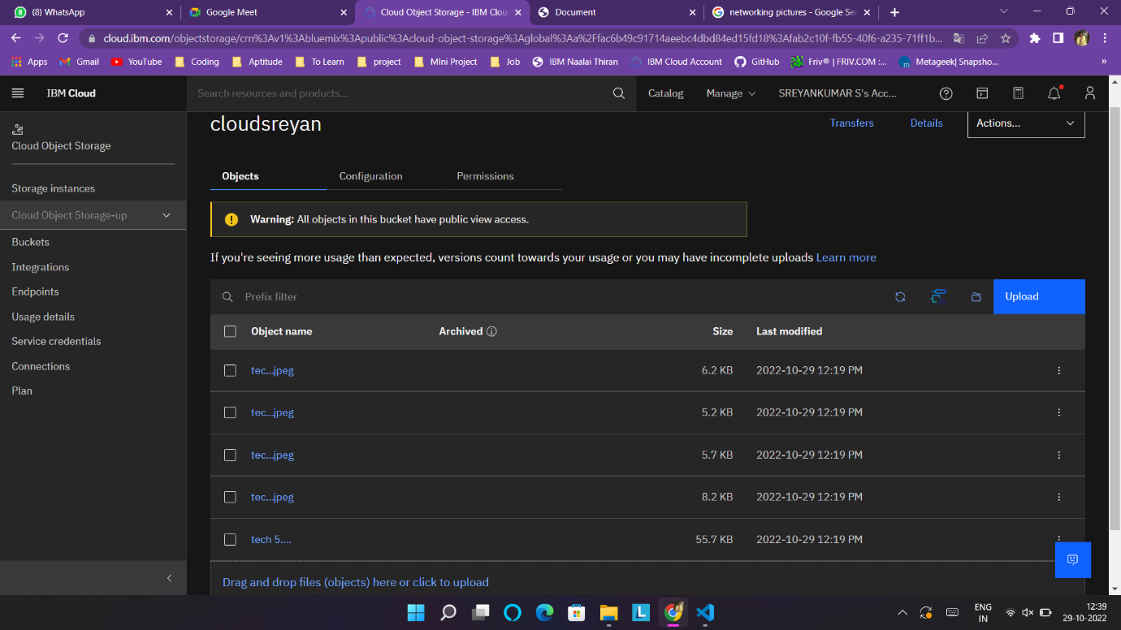

**2.Upload 5 images to IBM object storage and make it public. write html code to displaying all the 5 images:**

**Html code**

<!DOCTYPE html>

<html lang="en">

<head>

<meta charset="UTF-8">

<meta http-equiv="X-UA-Compatible" content="IE=edge">

<meta name="viewport" content="width=device-width, initial-scale=1.0">

<link rel="stylesheet" href="style.css">

<title>Document</title>

</head>

<body>

<img src="https://cloudsreyan.s3.jp-tok.cloud-object-storage.appdomain.cloud/tech%201.jpeg" alt="loading">

<img src="https://cloudsreyan.s3.jp-tok.cloud-object-storage.appdomain.cloud/tech%202.jpeg" alt="loading">

<img src="https://cloudsreyan.s3.jp-tok.cloud-object-storage.appdomain.cloud/tech%203.jpeg" alt="loading">

<img src="https://cloudsreyan.s3.jp-tok.cloud-object-storage.appdomain.cloud/tech%204.jpeg" alt="loading">

<img src="https://cloudsreyan.s3.jp-tok.cloud-object-storage.appdomain.cloud/tech%205.png" alt="loading">

</body>

</html>

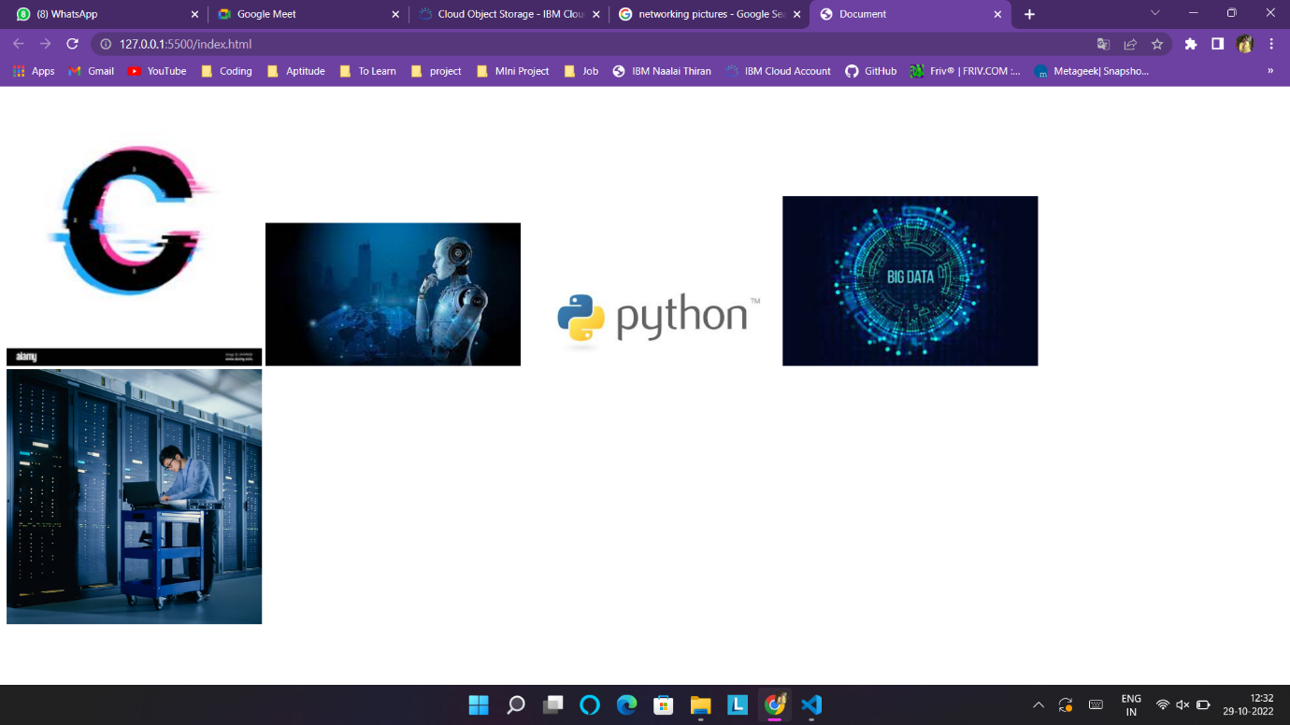

**3.Upload a CSS style sheet to the object storage and use the same page in your HTML**

img{

width: 20%;

height: 50%;

}



**4.Design a chatbot using IBM Watson assistant for hospital. Ex: User comes with query to know the branches for that hospital in your city.**

<https://web-chat.global.assistant.watson.appdomain.cloud/preview.html?backgroundImageURL=https%3A%2F%2Fau-syd.assistant.watson.cloud.ibm.com%2Fpublic%2Fimages%2Fupx-c282a80c-b0a9-48d6-a72c-3cdbe55e85a7%3A%3A8b3c2d73-4a41-4736-93d3-4566be80bc12&integrationID=4749bfee-90a2-4854-a108-de5b8cd87cc5&region=au-syd&serviceInstanceID=c282a80c-b0a9-48d6-a72c-3cdbe55e85a7>

**5.Create Watson assistant service with 10 steps and use 3 conditions in it. Load that script in HTML page.**